

**(An autonomous institution with A Grade by NAAC /UGC, Affiliated to Visvesvaraya Technological University, Belgaum, Approved by UGC/AICTE/Govt. of Karnataka)**

**Yelahanka, Bengaluru-560064**

# ACADEMIC YEAR 2020-2021

# COACHING INSTITUTE MANAGEMENT SYSTEM



Submitted by

**PAWAN KUMAR(1NT17IS121)**

**N ADITYA NAYAK(1NT17IS099)**

Submitted to

# "MOHAN KUMAR T G"

Department of ISE



WEB TECHNOLOGY LAB

**NITTE MEENAKSHI INSTITUTE OF TECHNOLOGY**

**Yelahanka, Bengaluru-560064**

**CERTIFICATE**

This is to certify that the Major Project report entitled Coaching Management System is submitted by PAWAN KUMAR & N ADITYA NAYAK for the partial fulfillment of the requirement for the award of the degree of BACHELOR OF ENGINEERING in INFORMATION SCIENCE & ENGINEERING from NITTE MEENAKSHI INSTITUTE OF TECHNOLOGY Bengaluru(Yelahanka).

**ACKNOWLEDGEMENT**

We sincerely express indebtedness to esteemed and revered guide **MOHAN KUMAR T G** of Department of Information Science and Engineering for his invaluable guidance, supervision, and encouragement throughout the work. Without his kind patronage and guidance, the synopsis would not have taken shape.We owe sincere thanks to all the faculties in Department of Information Science and Engineering for their advice and counseling time to time.

**TABLE OF CONTENTS**

* ABSTRACT
* INTRODUCTION
* PURPOSE OF PROJECT
* PROJECT & PRODUCT OVERVIEWS
* HOW IT BENEFITS A CANTEEN
* HOW IT BENEFITS A CUSTOMER
* TEAM ARCHITECTURE
* Requirement gathering and planning
* Designing and Backend
* OVERALL DESCRIPTION
* PRODUCT PERSPECTIVE
* OBJECTIVE
* REQUIREMENTS
* DESIGN
* SOME SCREENSHOT OF OUR WEB-PAGE

**ABSTRACT**

The Project “Coaching Institute Management System”. We introduce a new software product for handling activities takes place inside coaching institutes.

Now a days there is a tremendous increase in the activities

takes place inside the coaching institutes. The “Coaching

Institute Management System” is a software product to

automate and log on to various day-to-day activities and to

provide instantaneous information required in effective

management of any coaching institute. The automation part of

the software would involve data capture and maintenance of

details on the institute, staff, students and tasks in the overall

management of the institute. In the existing system we can

stored all the record manually that required large man power

and place to store the records. Due to manual maintains lots of

faults are occurred so needed to replace existing system by

automated software system. Automated system is time saving

and gives better performance than manual based system.

**INTRODUCTION**

Coaching Institute management software is a complete

solution for managing an administration. In other words an

enhanced tool that assists in organizing the day-to-day

activities of the coaching institutes.

Coaching institute management system centralizes

institute by providing features to its Administration,

Students, Staffs. The attendance review shows all students,

staffs absent today and students absent for the current

marking period, select students and parents for SMS

communications, click on student's name to see

demographic information to call parents, detail level

absenteeism, comments entered by teachers/office staff.

Administrator can keep eye on the regular money

transactions and institute fees collection program can be

customized according to institute rules. Data in the systems

can be analysed, graphed and reported in the format of

user's choice. Administrators are provided with a full

control over this software. Administration can send

announcements of the events to all users in the institute.

Students are provided with user ids and password. Students

can access their full details regarding marks, fees,

examination results. Parents can access the details of their

wards report card, performance, comments from teachers

and everything related to their ward.

This system provides a simple interface for the

maintenance of student and staff information. It can be

used by educational institutes to maintain the records of

students easily.

**PURPOSE OF PROJECT**

This software project is a Coaching Institute management system. It consists of all the data management and storage facilities that are required for effectively managing a class or tution teaching multiple courses and subjects. It consists of multiple teachers and faculty accounts along with their payment status. The system helps in effectively managing and scheduling batches of students as per their courses and exam priorities. The class management system allows the administrator to view and edit data as required. Administrator is notified of various events such as faculty contract renewal, fees date, student or batch fees payment date and other useful events as and when needed.

* The project overcomes all the manual approach of maintaining class information on paper by automating.
* As the system is fully automated, it does not require human efforts in calculating and maintaining faculty and student’s fees details.
* Also it maintains records of all the employees along with their salary information so there would be systematic way of payment.
* Saves efforts and time and it is cost-effective.

**PROJECT & PRODUCT OVERVIEWS**

A complete canteen management system makes canteen workers monitor overall day to day business analytics more accurately with an ease. It increases the presence of canteen fascinates core customers towards your food business leading to increased sales.

By bringing all necessities in one place canteen management system benefits both the user as well as the canteen owner smartly. Ultimately all business operation will be mad easier and single handed with the required inbuilt features.

The working of canteen management system is similar to an e-commerce website. Whenever your customers are busy with their work, instead of coming to your canteen they can just open your website, choose the menu they like and can simply order food.

As soon as order gets placed, you will be notified immediately, so that you can start order processing. One of the main advantages of canteen automation system is the order details are accurate when compared to the phone ordering system or manual system.

**HOW ITS BENEFITS A COACHING**

This module will help you to make the enquiry system well

organized in terms of look into & intensify utilization of

time as it works on automated system. Since admission

depends upon the number of enquiries & how it is being

handled & followed up on.

Features:

* Online enquiry form.
* Course wise inquisition system.
* Maintain direct or head-on enquiry, telephonic

enquiry & online enquiry. ·

* Automated email/SMS follow up system.
* Customization of email/SMS contents can be done

anytime according to need.

**HOW IT BENEFITS A STUDENTS**

The student module enables you to accumulate all personal,

academic, professional and history data regarding the

students.

Features:

* Maintain record of all important details about

every student. Record can be edited as per

requirement.

* Change of course & batch can be done simply.
* Students record can be filtered based on the course

& batch.

**TEAM ARCHITECTURE**

There were total 2 members in our project. The complete project is divided into two teams:-

**TEAM 1**

**REQUIREMENT GATHERING & PLANNING**

The school management system which capable of sorting school resources.Such as students and staff of the school and their relation was implemented.It is easy to track the relations of students and courses they taken courses

And teacher they are given by using the friendly interface of the system.

This application runs on local machine for management of one school. This Application is user friendly. This application helps students, teachers to Gather their personal and academic materials and information’s in a Organized manner. It is easy to track school management system.

In future I will work with high security system. Anyone can use this Application from anywhere with several browser.

Thus, a proper planning and requirement gathering leads to an efficient software system.

**TEAM ARCHITECTURE**

**TEAM 2**

**DESIGNING AND BACKEND**

Designing is the most important and the most efficient function while software development. Without a proper design, it is very difficult to develop an appropriate software that fulfills nearly all user demands. Therefore, managing designing part in an organization is a critical activity. A designer needs to ensure that the design created by him can be easily understood by the all the members of developing a team. A proper design will allow the coder to implement the system development planning properly. Similarly, the backend part that includes the database management plays a key role in any of the systems. Thus, the team working on this field must know proper handling and management of database and its tools.

**OVERALL DESCRIPTION**

* **Time Saving:** Our Coaching Institute Management System is developed with a primary aim of 'Saving Time. The students can pay their fee and it is also efficient for office workers because this system takes lesser time as compared to offline fee payement based or manually based system.
* **No Complication:** Major complication part for Coaching Institute Management System is adding a notes or managing notes section. In our Coaching Institute Management System, no complicated part is involved in managing sections; we have taken immense care in this section and nullified all complications which make this system accurate and unique.
* **Cost Effective:** It's cheaper. You don't have to purchase multiple copies of software to install on multiple computers. Multiple copies often require you to pay multiple licensing fees, but since you aren't actually purchasing any software with an online system, that's not a concern.
* **Security:** Online systems are just as secure. Most online Coaching Institute Management System programs allow you to create multiple user accounts with various levels of access. Your data is stored on secure, protected servers that feature firewalls and other online security programs.

**PRODUCT PERSPECTIVE**

The system will be developed using HTML, CSS,BOOTSTRAP,JAVASCRIPT,NODEJS and other Web tools like visual studio code.

**Product Functions**

The product developed will provide an easy access to the user to manage and alter the coaching automation according to the need.

**General Constraints**

* The cost constraint includes ordering additional hardware to run the new system.
* No current web-site.
* Security must be upgraded for online searching.

**Assumptions**

* The system will support all browsers.
* The processor must be at least Dual cored and can be any other latest ones etc.

**OBJECTIVE**

Our “Coaching Institute Management System” software

developed for an institute has been designed to achieve

maximum efficiency and reduce the time taken to handle

the storing activity. It is designed to replace an existing

manual record system thereby reducing time taken for

calculations and for storing data.

The system is strong enough to withstand regressive

daily operations under conditions where the database is

maintained and cleared over a certain time of span. The

implementation of the system in the organization will

considerably reduce data entry, time and also provide

readily calculated reports.

* Student Registration
* Attendance Management
* Fee Payment
* Course Update

The above are the modules of Coaching Institute management system.

**REQUIREMENTS**

**HARDWARE REQUIREMENTS**

Here's what you Need to Use the canteen management system for online records:

* Minimum 20 GB HDD
* Minimum 256 MB RAM
* Pentium IV Processor
* **Input Devices:** Keyboard, Mouse
* **Output Devices:** Monitor, Printer

**SOFTWARE REQUIREMENTS**

* **Operating System:** Window XP and above.
* **Browsers :** Chrome or any other latest web page supporting browser.
* Visual studio code or any other similar software.

**DESIGN**

**USE CASE DIAGRAM**

A use case is a description of how end-users will use a software code. It describes a task or a series of tasks that users will accomplish using the software and includes the responses of the software to user actions.

**LOGIN PAGE USE CASE DIAGRAM**

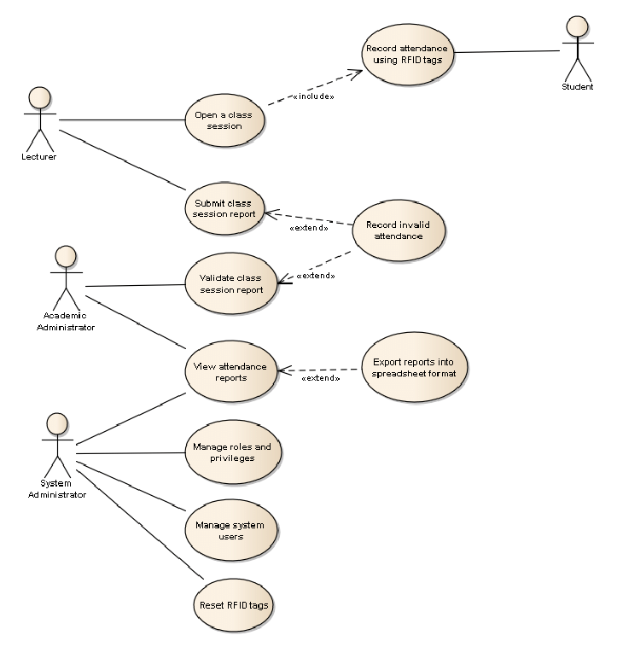

**STEPS TO RUN**

Save the project folder on the path where the node and mongo is installed.

* Installation Process using Terminal
* npm install express --save
* npm install ejs --save
* npm install mongoose --save
* Run the project
* $ cd IIGNISER1
* $ node app.js
* Go to your browser & type
* localhost:3000
* Now,your project will display on the web page.

#FRONTEND -->PAWAN KUMAR

#BACKEND -->N ADITYA NAYAK

**SOME SCREENSHOT OF OUR WEBPAGE**

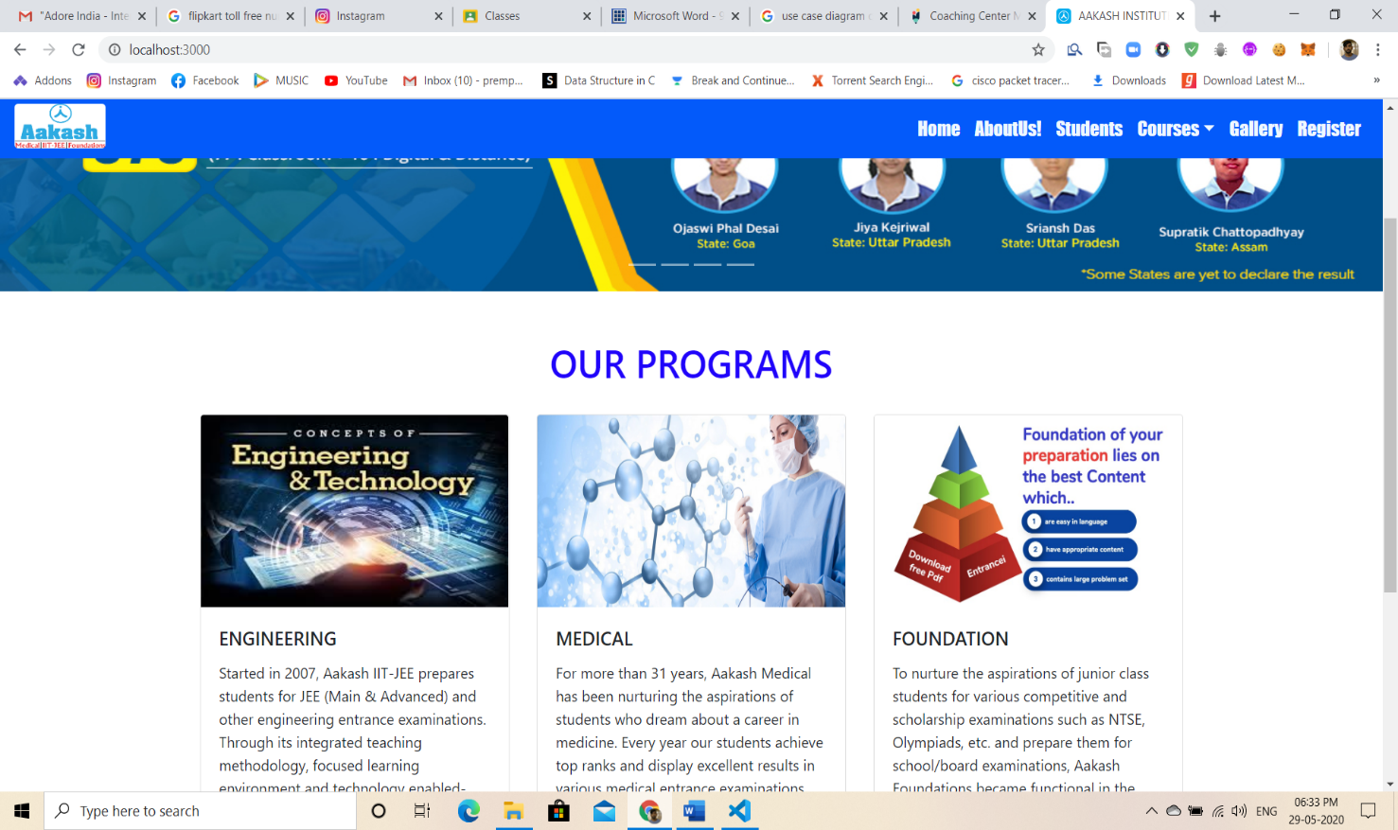

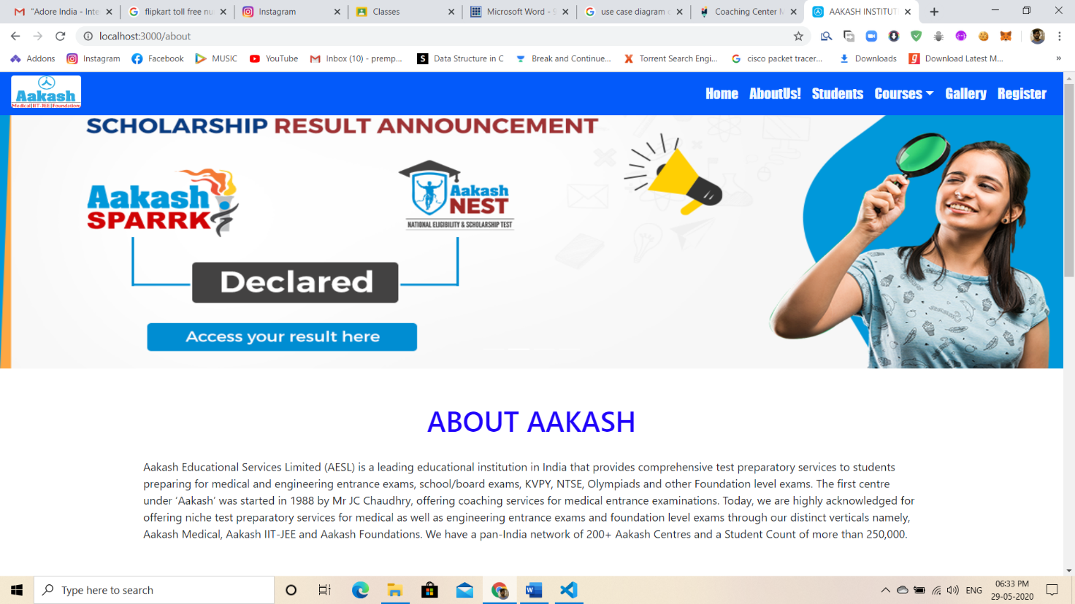

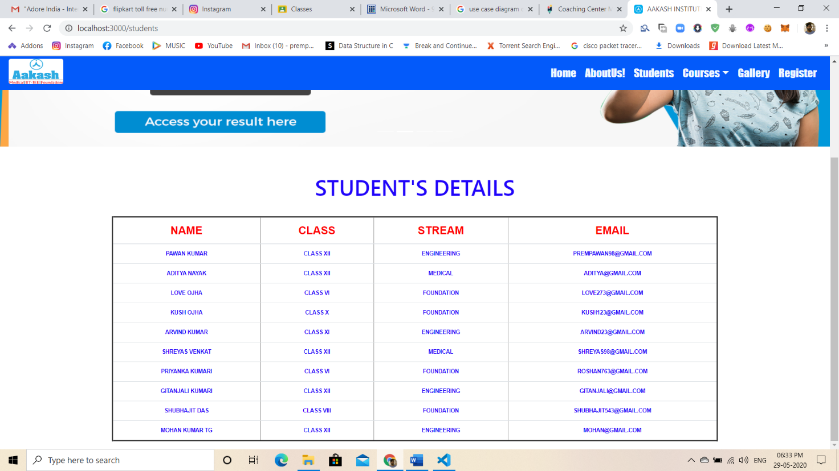

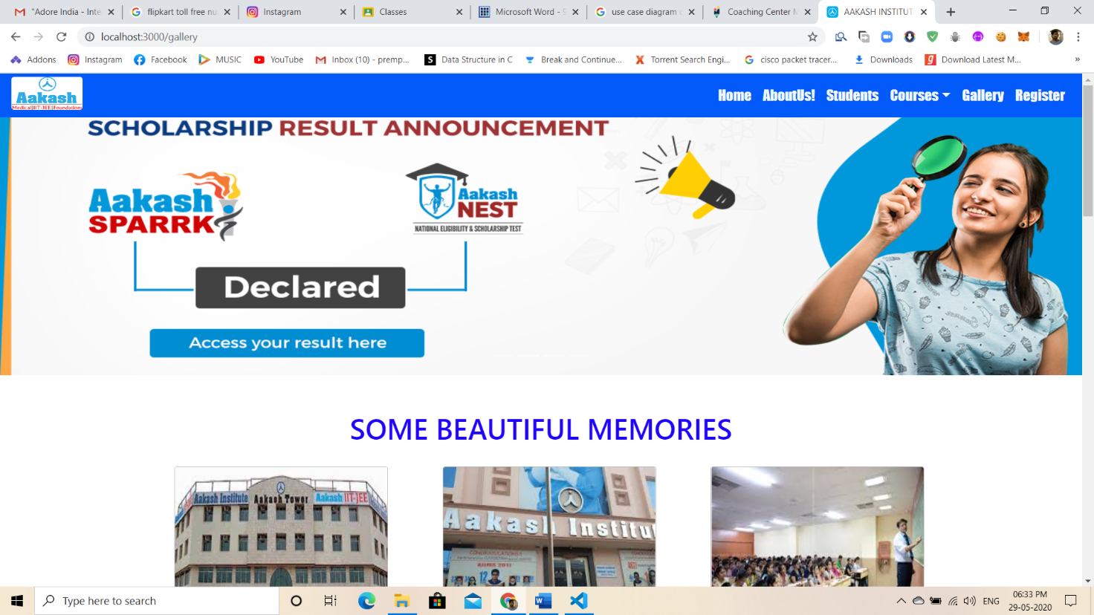

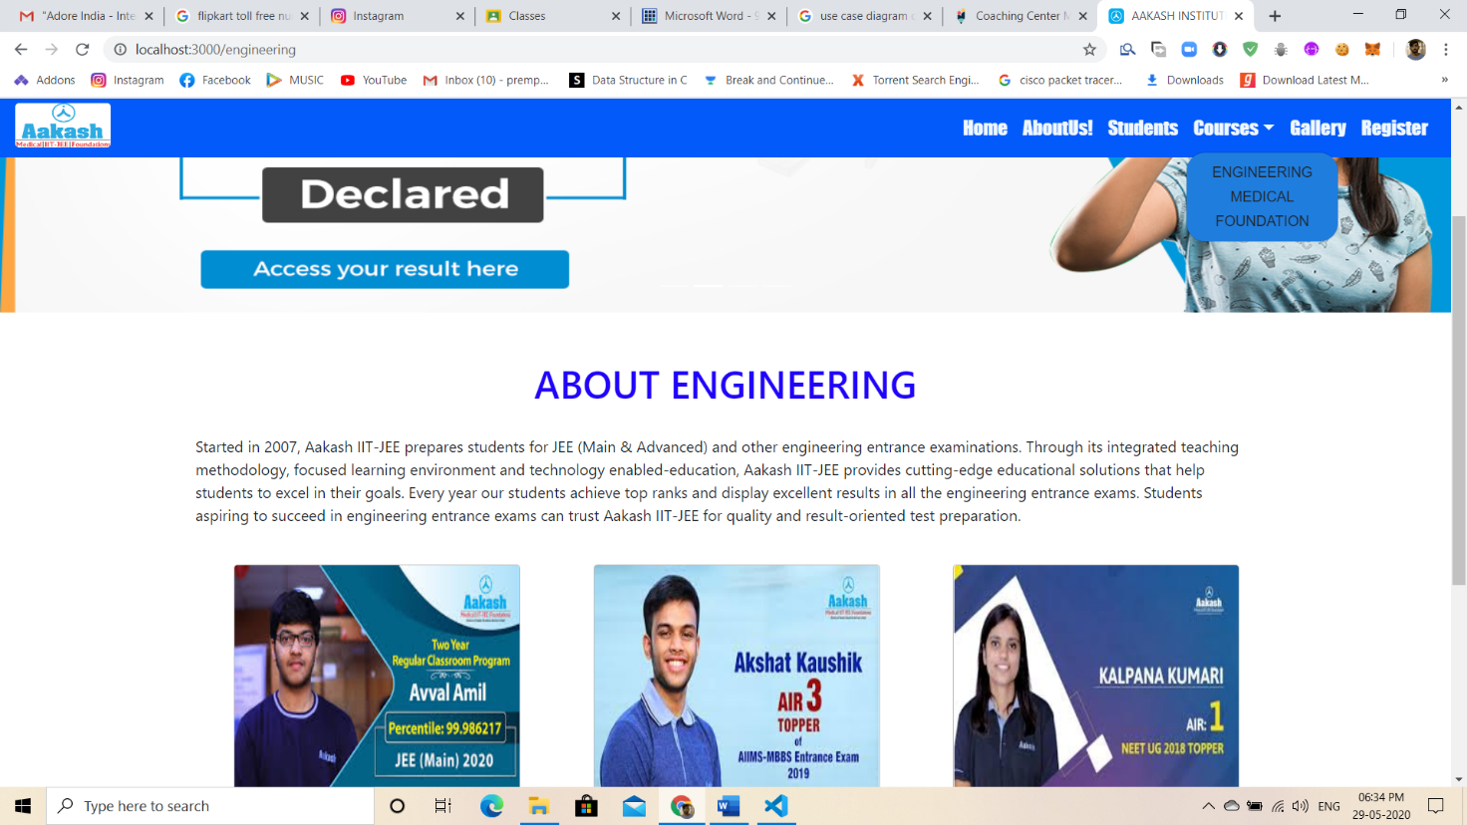

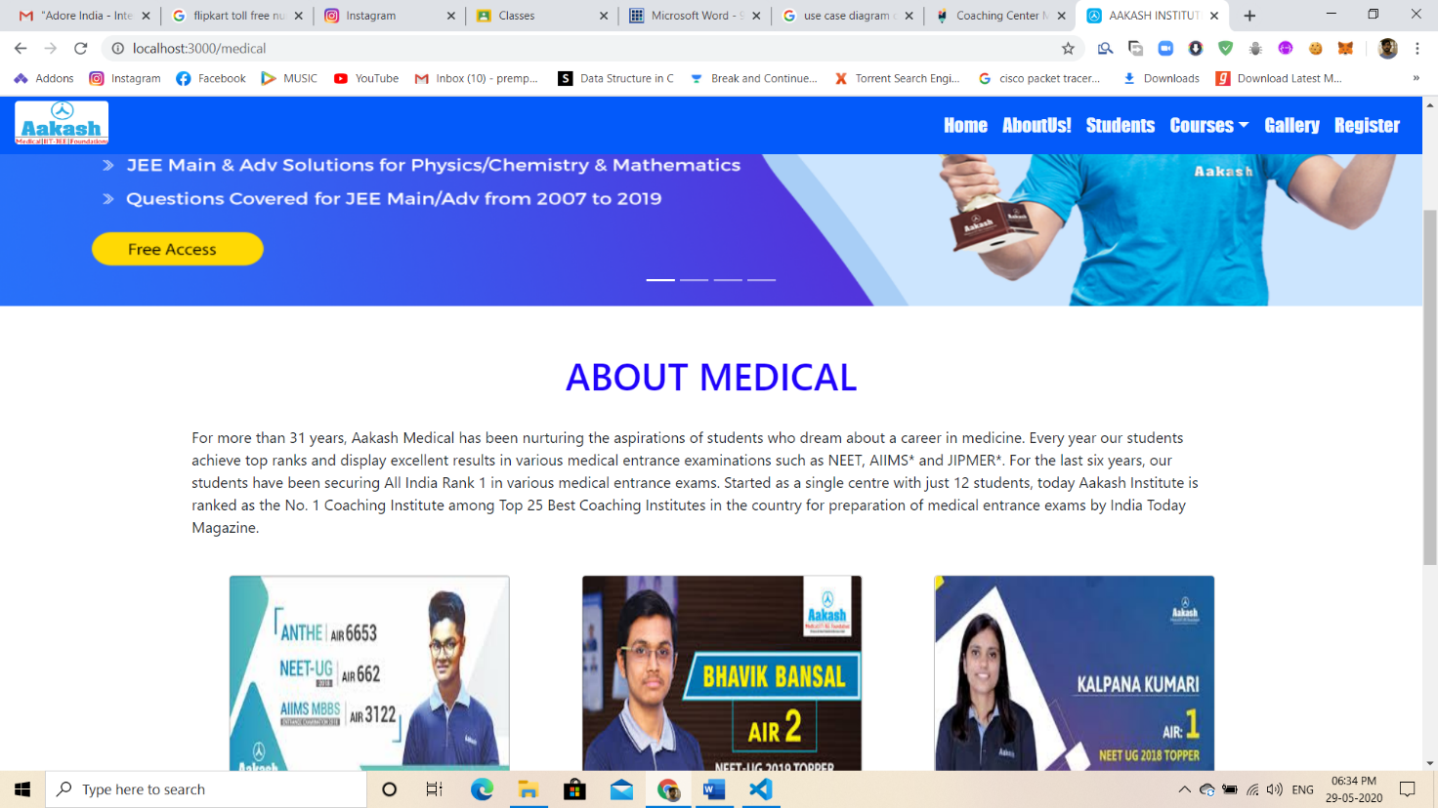

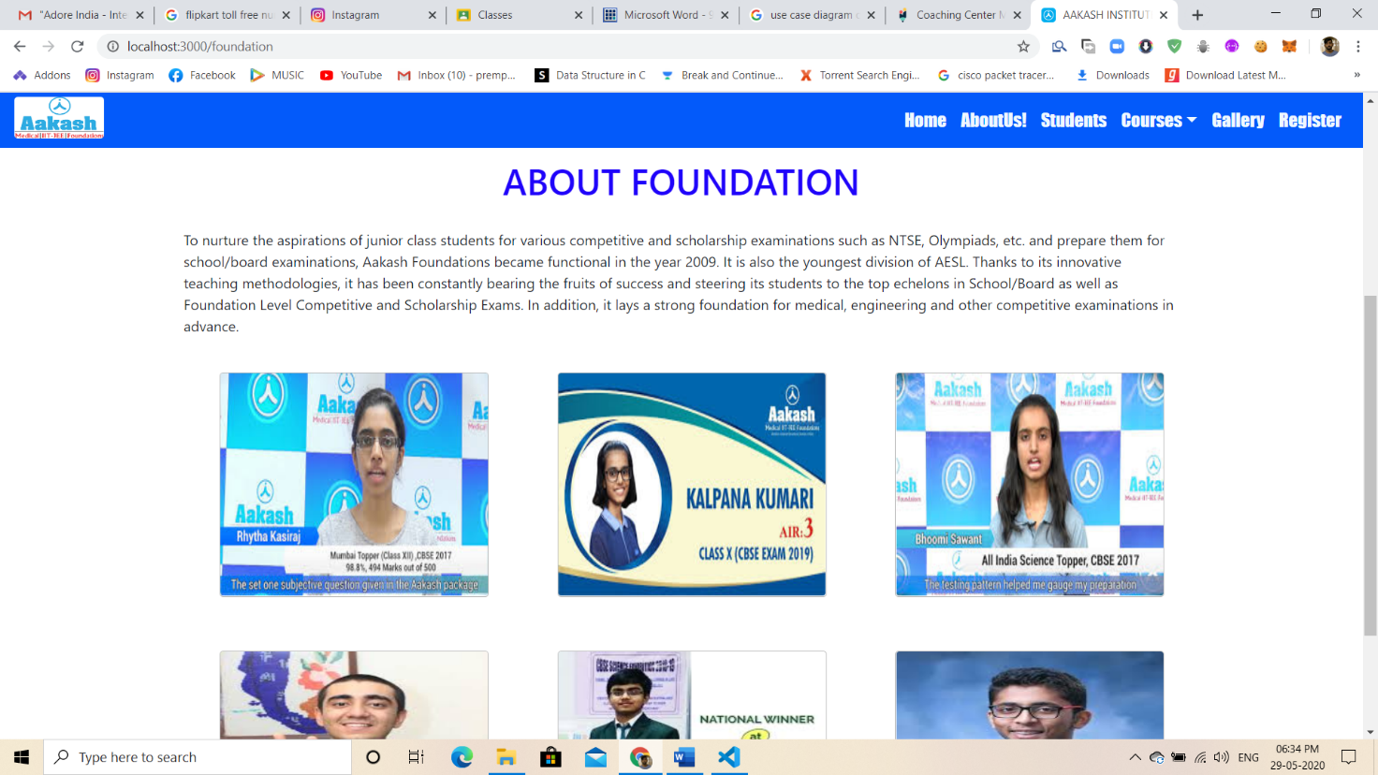

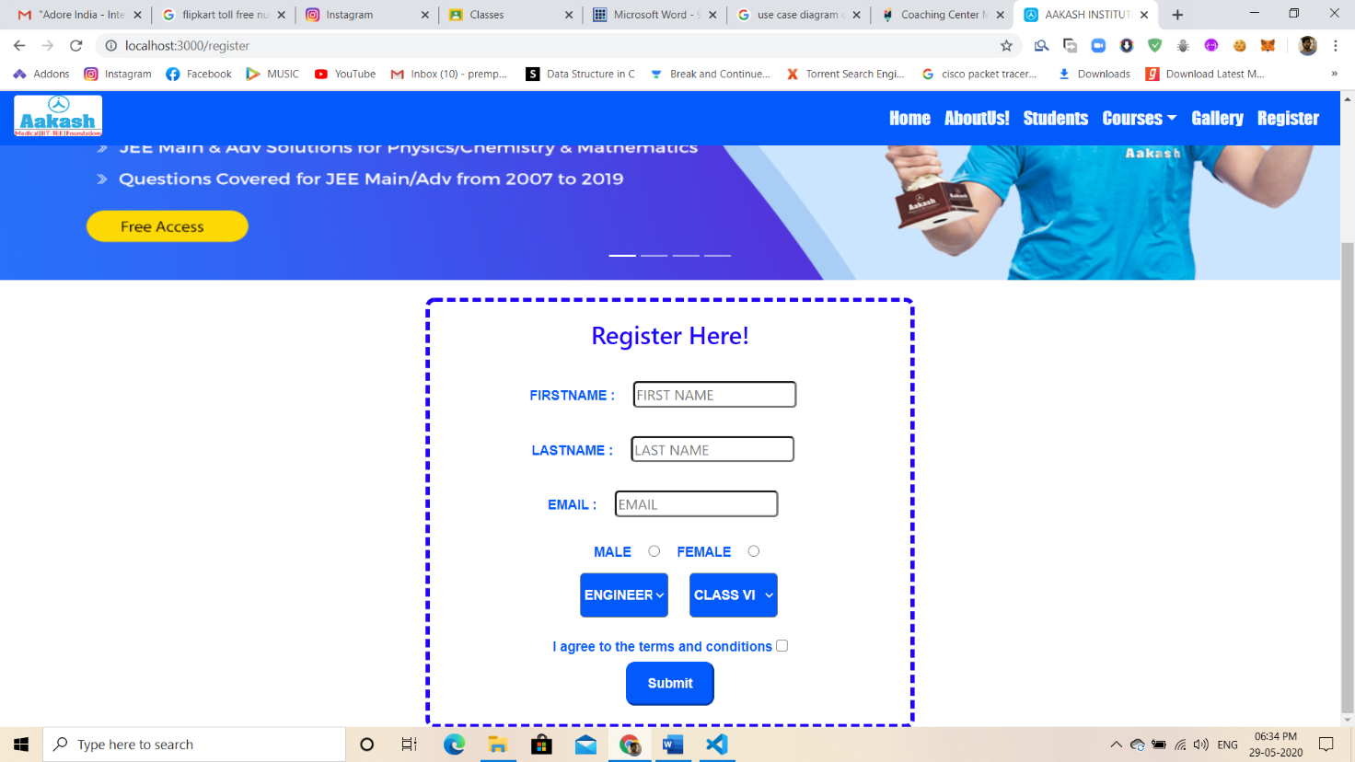

**!!!THANK YOU!!!**